Snapshot Isolation Demo

use Master
go
create database SIDemo
go
use SIDemo
go
create table customer_transactions
(custid char(4),
cname varchar(20),
Bill_Amt int)
go
Insert Into customer_transactions Values('C1','John', 900)
Insert Into customer_transactions Values('C2','Martin', 200)
Insert Into customer_transactions Values('C3','Smith', 800)
Insert Into customer_transactions Values('C4','Roger', 700)
go
select * from customer_transactions

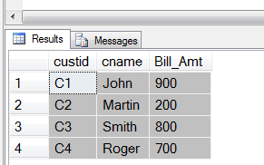

This is the situation till the previous day.

There are two users Allen and King.
King is the boss of Allen.
Allen will do DML on the above table daily.
King needs to have a view of the yesterday’s committed records only of the table even if concurrently Allen commits the changes to the same table.

--Script of logins, users,schemas,table privileges and database role
create login allen
with password = N'allen',
default_database=SIDemo,
check_expiration=off,
check_policy=off
go

create user allen for login allen
go

create login king
with password = N'king',
default_database=SIDemo,
check_expiration=off,
check_policy=off
go

create user king for login king
go

Alter user allen
with default_schema=dbo
go

Alter user king
with default_schema=dbo
go

grant select,insert,delete,update on customer_transactions to allen
go
grant select,insert,delete,update on customer_transactions to king
go

--To set the Snapshot Isolation Level the user must be assigned the db_owner database role

ALTER AUTHORIZATION ON ROLE::[db_owner] TO [king]
GO
USE [SIDemo]
GO
EXEC sp_addrolemember N'db_owner', N'king'
GO

Close SSMS entire Application.

Start SSMS again.

Next morning King log’s in at 9:30 am.

He will the set the Snapshot Isolation level in his session.

Start a new SSMS window through King’s login (Not Window’s Authentication!)

-- King's Session
Alter Database SIDemo
Set Allow_Snapshot_Isolation On
go
Use SIDemo Set Transaction Isolation Level Snapshot
go
Begin Transaction

Select * from customer_transactions -- Default 4 rows

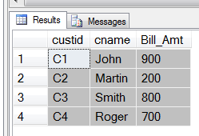

After 15 minutes, i.e. at 9:45 am Allen log’s in

Start a new SSMS application through Allen’s login
(Do NOT click on New Query of King’s session)

Start a new Application window of SSMS (Not Window’s Authentication!)

-- Allen's Session

Begin Tran
Insert Into customer_transactions Values('C5','Miller', 500)
Select * from customer_transactions

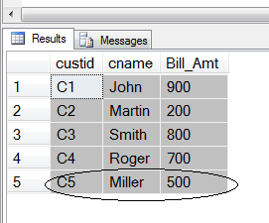

Go back to King’s login
-- King's Session

Select * from customer_transactions -- No lock/wait and has 4 rows!!!!!!!!!!!!

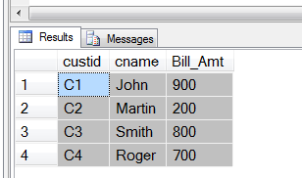

Now Allen commits his transaction

-- Allen's Session

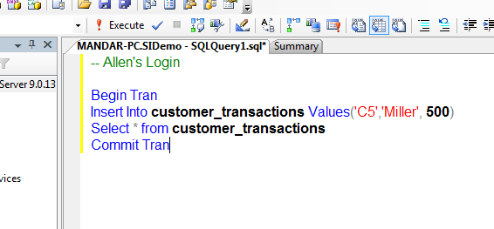

Commit Tran

Let us see the effect of this commit on King’s session
-- King's Session

Select * from customer_transactions -- Still 4 rows only !!!

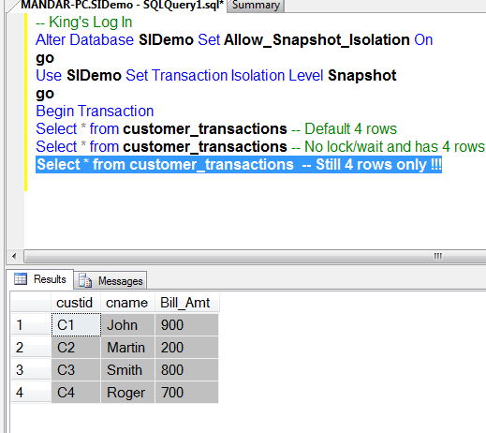

Now King commits his transaction

-- King's Session

Commit Tran

Select * from customer_transactions -- After commit gets all the 5 rows

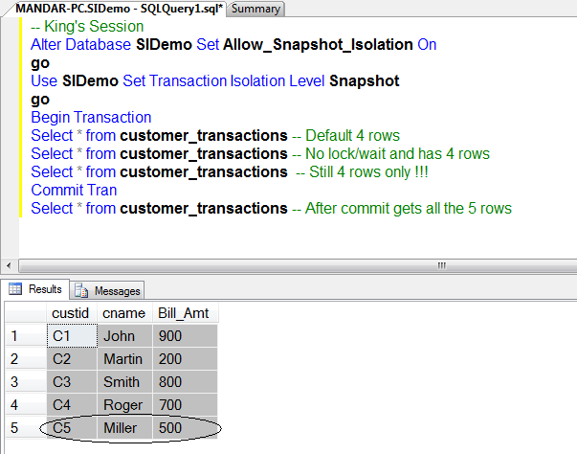

The session having snapshot isolation level cannot update or delete the rows which are currently updated or deleted by any other concurrent session (s)

Session one:

Alter Database SS Set Allow_Snapshot_Isolation On
Use SS Set Transaction Isolation Level Snapshot
Begin Transaction

Session two:
begin tran
update emp
set sal = 6000
where ename = 'KING'

Session one:
update emp
set sal = 7000
where ename = 'KING' -- ..... waiting mode

delete from emp where ename = 'KING' -- ..... waiting mode

Clean Up Code:

- Close both the SSMS Application Window’s of King and Allen. (No need of saving the script file for both the Windows)
- Open SSMS through regular Windows Authentication
- Execute the following code to drop the database:
Use Master
go
drop database SIDemo
go
- Execute the following code to drop both the logins.
Use Master
go
Drop Login Allen
go
Drop Login King
go

